**Force Sensing Resistor**

FSRs are sensors that allow you to detect physical pressure, squeezing, and weight. They are simple to use and low-cost.  This is a photo of an FSR, specifically the Interlink 402 model. The 1/2" diameter round part is the sensitive bit.

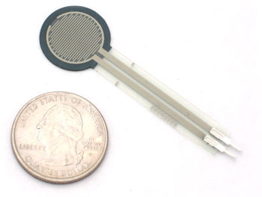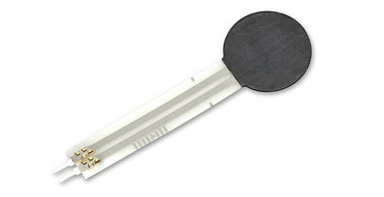

The FSR is made of 2 layers separated by a spacer. The more one presses, the more of those Active Element dots touch the semiconductor and that makes the resistance go down.

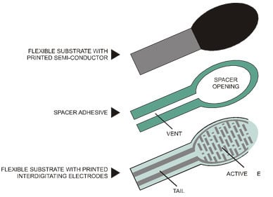

**Some Basic Stats**

* **Size:** 1/2" (12.5mm) diameter active area by 0.02" thick (Interlink does have some that are as large as 1.5"x1.5")
* **Price** [$7.00 from the Adafruit shop](http://www.adafruit.com/products/166)
* **Resistance range:** Infinite/open circuit (no pressure), 100KΩ (light pressure) to 200Ω (max. pressure)
* **Force range**: 0 to 20 lb. (0 to 100 Newtons) applied evenly over the 0.125 sq in surface area
* **Power supply:** Any! Uses less than 1mA of current (depends on any pullup/down resistors used and supply voltage)
* [Datasheet](http://learn.adafruit.com/system/assets/assets/000/010/126/original/fsrguide.pdf)(note there are some mathematical inconsistancies in here)

**How to measure force/pressure with an FSR**

 the FSR's resistance changes as more pressure is applied. When there is no pressure, the sensor looks like an infinite resistor (open circuit), as the pressure increases, the resistance goes down. This graph indicates approximately the resistance of the sensor at different force measurements.

(Note that force is not measured in grams and what they really mean is Newtons * 100!)

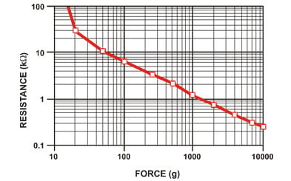

It is important to notice that the graph isn't really *linear* (its a log/log graph) and that at especially low force measurements it quickly goes from infinite to 100KΩ.

**Analog Voltage Reading Method**

The easiest way to measure a resistive sensor is to connect one end to Power and the other to a **pull-down** resistor to ground. Then the point between the fixed pulldown resistor and the variable FSR resistor is connected to the analog input of a microcontroller such as an Arduino

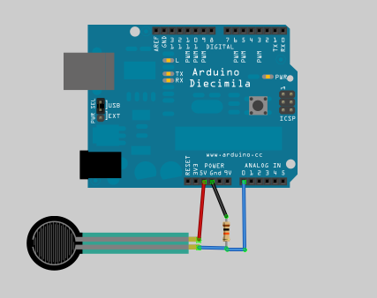

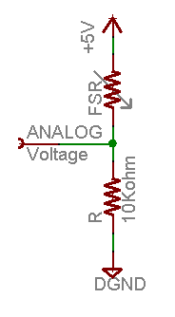

the total resistance of the FSR and the pulldown resistor decreases from about 100Kohm to 10Kohm. That means that the current flowing through both resistors *increases* which in turn causes the voltage across the fixed 10K resistor to increase.

|  |  |  |  |  |  |
| --- | --- | --- | --- | --- | --- |
| **Force (lb)** | **Force (N)** | **FSR Resistance** | **(FSR + R) ohm** | **Current thru FSR+R** | **Voltage across R** |
| **None** | **None** | Infinite | Infinite! | 0 mA | 0V |
| **0.04 lb** | **0.2 N** | 30 Kohm | 40 Kohm | 0.13 mA | 1.3 V |
| **0.22 lb** | **1 N** | 6 Kohm | 16 Kohm | 0.31 mA | 3.1 V |
| **2.2 lb** | **10 N** | 1 Kohm | 11 Kohm | 0.45 mA | 4.5 V |
| **22 lb** | **100 N** | 250 ohm | 10.25 Kohm | 0.49 mA | 4.9 V |

**The voltage equasion is:**

**Vo = Vcc ( R / (R + FSR) )**

That is, the voltage is proportional to the **inverse** of the FSR resistance.

**Programming for Force Sensor**

const int forcePin = A0; // Analog input pin for force sensor

const float voltageRef = 5.0; // Reference voltage of Arduino (5V)

void setup() {

  Serial.begin(9600); // Initialize serial communication

}

void loop() {

  int sensorValue = analogRead(forcePin); // Read the analog value from the force sensor

  float voltage = sensorValue * voltageRef / 1023.0; // Convert the sensor value to voltage

  //float weight = ((sensorValue*6)/1024)-3;

  // Assuming you have calibration data for your specific force sensor,

  // you can calculate the pressure in Newtons using a formula.

  // Replace the calibration values with your own.

  float calibrationFactor = ; // Calibration factor for your specific sensor

  float pressure = voltage * calibrationFactor;

  Serial.print("Analog value: ");

  Serial.println(sensorValue);

  Serial.print("Voltage value: ");

  Serial.print(voltage);

  Serial.println("v");

 // Serial.print("Weight: ");

 // Serial.print(weight);

  Serial.print("Force (N): ");

  Serial.println(pressure);

  delay(2000); // Delay for stability or adjust as needed

